# **AMERICAN SHAD AND BLUEBACK HERRING STUDIES**

## **Study Title: Region IV-American Shad Project**

Period Covered: January 2025–April 2025

**Introduction**

The American shad (*Alosa sapidissima*) is an anadromous species that ranges from Florida to Nova Scotia and is found in most of the rivers along the Atlantic coast of the United States. American shad are currently managed by the Atlantic Marine Fisheries Commission (ASFMC) under that Atlantic Coastal Fisheries Cooperative Management Act (ACFCMA), passed in 1993. ACFCMA presented a new and innovative approach to coordinated management of coastal migratory fisheries along the US Atlantic coast, including mandated state implementation of a fishery management plan (FMP) for each fishery resource species. South Carolina continues to manage fishery conservation programs at a conceptual and practical level to remain in compliance with guidelines established in ACFCMA. The primary data collection objectives are to demonstrate sustainability for South Carolina Rivers through collecting and analyzing fishery-independent and fishery-dependent data, biological age and length data, and commercial harvest data. The American shad sustainable fishery management plans (SFMP) ensure proper and consistent resource management in South Carolina, as well as provide data necessary for trend analyses within and among states. Data are used in annual ASFMC American shad compliance reports and benchmark stock assessments, as well as determining best fishery regulations within state.

**Materials and Methods**

*Adult American Shad Fishery Independent Sampling*

Sampling sites were chosen based on their seaward position from any known contemporary shad fishery activities. Tagging fish seaward of areas commonly used by commercial fishermen helps prevent immediate recaptures before shad resume natural movements. Netting effort for the purposes of this study was defined in “net hours,” where one net hour equals one 91.44-meter (m) drift for 1 hour. Captured fish were measured to the nearest fork length (FL) and total length (TL) in millimeters (mm). In previous years, an external dart tag was placed in the dorsal musculature of each fish prior to release downriver of the sample site. However, due to low or no tag returns in many years the angler incentive program was discontinued in 2024.

Santee River

Sampling conducted in the Santee River (river kilometer [rkm] 21) focused on capturing adult American shad to establish catch rates and provide length data used in stock structure analysis (Figure 1). This location is frequently used for commercial fishing and is tidally influenced, with a reversal of flow upstream during flood tides. The channel width at this sampling site is 150 m with water depths at mean low tide ranging from 4-8 m. Sampling gear consists of 68.58 m drift monofilament gill net with 12.70 centimeter (cm) stretched mesh, deployed during the incoming tide and retrieved using a 5.3 m open decked, outboard powered skiff. Depending on the tidal stage, either a 5.08 m deep or a 6.35 m deep net were used. Water temperature, salinity, and dissolved oxygen parameters were recorded at the beginning and end of each sampling drift using a YSI meter.

Waccamaw River

Sampling conducted in the Waccamaw river (rkm 34.4) focused on capturing adult American shad to establish catch rates and provide length data used in stock structure analysis (Figure 2). This location is also frequently utilized for commercial fishing and tidally influenced. The channel width at this sampling site is 250 m with 10 m water depth at mean low tide. Sampling gear consists of a 132.59 m and 9.53 m deep drift monofilament gill net with 12.70 cm stretched mesh, deployed and retrieved using a 5.3 m open decked, outboard powered skiff. Water temperature, salinity, and dissolved oxygen parameters are recorded at the beginning and end of each sampling drift using a YSI meter.

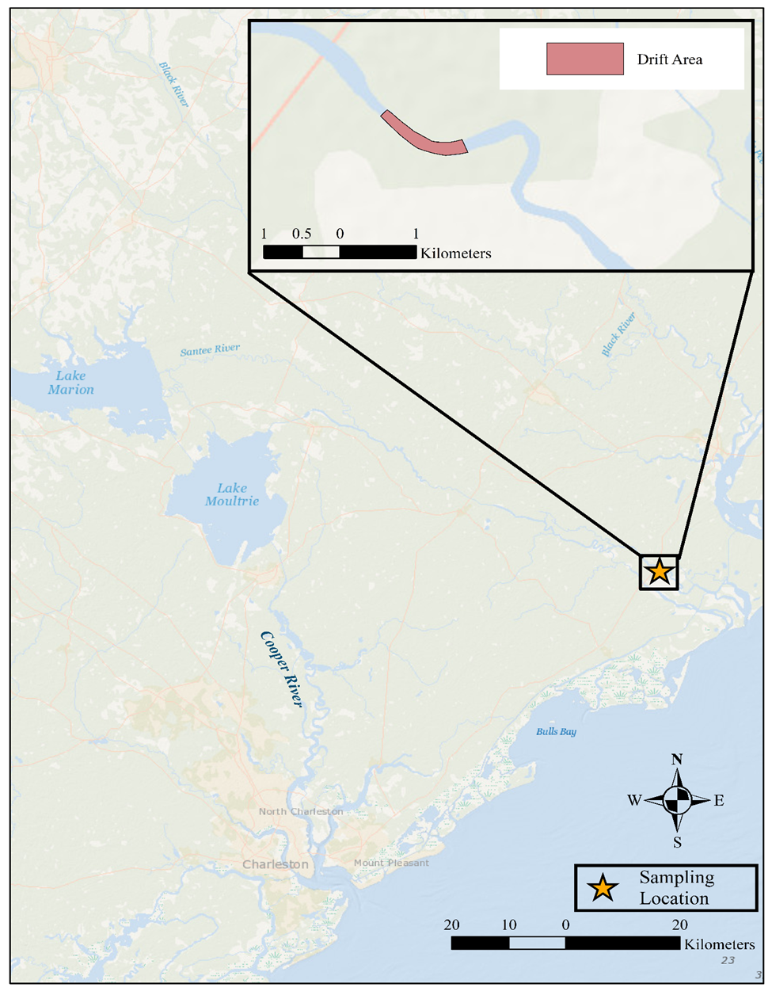

### Figure 1. Map of sampling location in the Santee River.

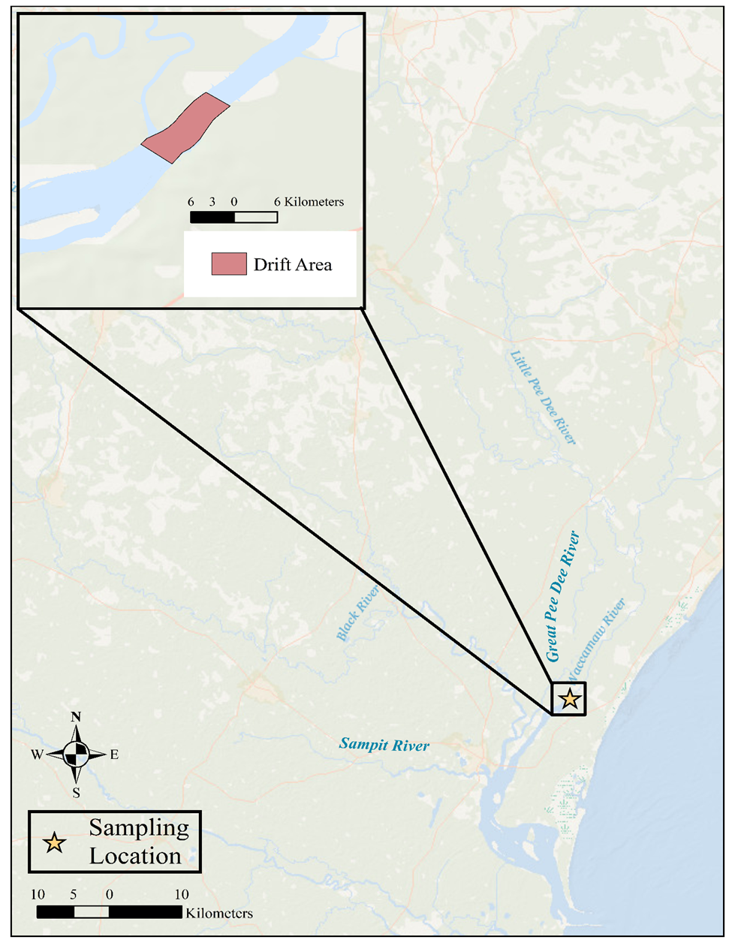

### Figure 2. Map of sampling location in the Waccamaw River.

*Adult American Shad Fishery Dependent Sampling*

Amendment 1 to the ASMFC FMP for American Shad requires that those states with active commercial fisheries, including South Carolina, collect biological data annually to gather age and length information. Scale and otolith samples were collected from random selections of shad from the commercial gill net fishery; these collections were distributed throughout the open netting season. All fish were sampled from local fish houses and were representative of the commercial fishery, which uses 13.97 cm stretched mesh drift gill nets. Shad scales were washed and cleaned using a light abrasive cloth to remove mucus and pigmentation. The scales were pressed and dried for several weeks, then examined using a microfiche reader to assign ages using the method described by Cating (1953). Otoliths were dissected, cleaned, and stored independently (per fish), and were visualized under dissecting microscope with a dark background and reflected light. Otoliths were placed sulcus down, and annuli were defined as full concentric breaks in translucent regions, with particular reference to the antirostrum region (Elzey et al. 2015; VanderKooy et al. 2020). Multiple readings were conducted per otolith, using up to three sessions, and all sessions were conducted without reference to a previously defined age or knowledge of individual fish length or sex. Age agreement was defined as the consensus between two assigned ages, and if no agreement was made between the three sessions, the otolith age was excluded. Mandatory reporting for the open commercial fishery requires effort to be recorded each fishing trip and reported each month, providing additional commercial harvest data for analysis.

*Juvenile American Shad Fishery Independent Sampling*

As in previous years, from mid-June through October, electro-fishing collections of young-of-the-year (YOY) juvenile shad and herring were made weekly at numerous predetermined nursery sites to determine relative abundance indices and timing of outmigration of juvenile shad from South Carolina watersheds. Sampling in the Santee Basin occurred at three fixed sites in the Congaree River, and four in the upper Santee River (Figure 3, 4). Sampling in the Savannah and Great Pee Dee Rivers occurred at three sites in each river. Sampling sites on rivers were selected from satellite imagery based on areas that were presumed to be preferred nursery habitat for YOY American shad. These habitats typically consist of sandbars occurring on the inside bend of rivers, ranging 1–2 meters (m) depth. River sites were visited during daylight hours, with a goal sampling frequency of two times per month, during which a single 0.25-hr sample per site was conducted. All fish collected were identified to the to species and total length was recorded for up to 20 AMS per site, which were preserved on ice (later frozen) for laboratory processing. In past years, after sampling concluded for the season, otoliths were extracted from preserved shad and viewed under a UV fluoroscope to identify fish displaying an oxytetracycline (OTC) mark, thus indicating a fish of hatchery origin. On January 1, 2017, the Food and Drug Administration issued a new rule that all veterinary antibiotics will be accessible only with veterinary oversight. OTC is a veterinary antibiotic and because of the change in the law, SCDNR chose to no longer mark individuals using OTC. Consequently, for the 2017 sampling season and thereafter, pectoral fin clips were collected from ~20 American shad per site per day for genetic analysis to determine potential hatchery contribution. Water quality measurements are taken at each sampling site to account for temperature, conductivity, dissolved oxygen, and salinity values. Additionally, from 2009 through 2023 this monitoring was conducted by the Diadromous Fishes Section staff with funding from the Santee Basin Cooperative Accord (Accord). Funding for this task from the Accord was discontinued in 2023 and sampling efforts were then divided between SCDNR freshwater fishery regions II, III, and IV, however all sampling methods remained the same. A related and continuing shad restoration program lead to sampling for juvenile American Shad in the Edisto River. This sampling is performed annually by USFWS staff from Bears Bluff National Fish Hatchery.

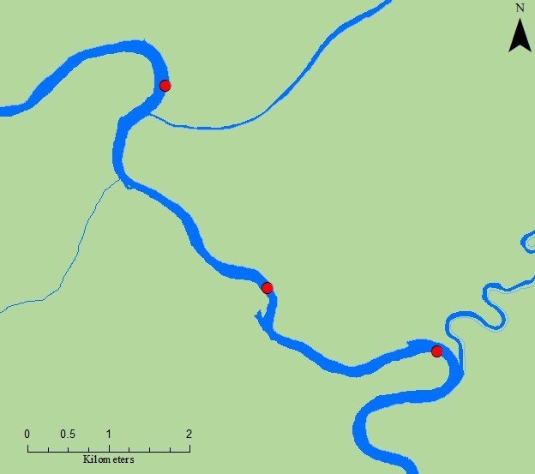

Site #3

Site #2

Site #1

US 601

### Figure 3. Congaree River sampling sites.

### Figure 4. Upper Santee River sampling sites.

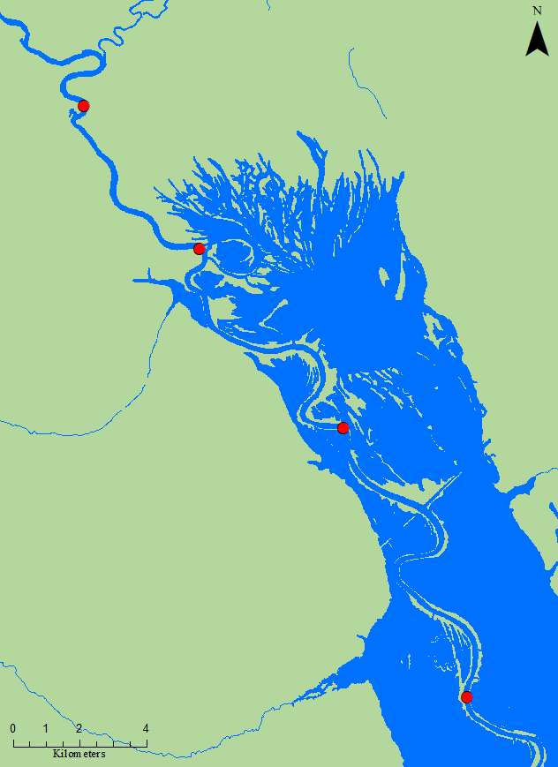

Site #4

Site #3

Site #2

Site #1

*Juvenile American Shad Collections*

Electrofishing occurred biweekly from early June through October in the Santee and Congaree Rivers, for a total of eight sampling trips. Concurrent sampling occurred in the Great Pee Dee and Savannah Rivers from late August through October, resulting in six sampling trips for both rivers. An additional five sampling trips occurred from the Edisto River, from early August through mid-September, terminating early due to the government shutdown in October.

*Data Treatment*

Site specific data were pooled to inform catch rates of AMS by river, defining within-season rates and allowing annual totals to be calculated. Efforts were summed and paired with the appropriate catch rate to standardize annual rates and demonstrate changes to survey design for the past two years. Standardized annual rates were plotted as individual series to visualize relative abundance trends through time in all rivers, and 25th percentiles were calculated from all available years to act as a baseline to qualify the strength of year classes.

**Results and Discussion**

*Adult American Shad Independent Sampling*

Santee River

From January 14 through April 8, 2025, 21 netting trips were conducted in the Santee River at the fixed sampling site. Efforts results in the capture of 31 American shad and consisted of 25 net set hours (Catch-Per-Unit-Effort [CPUE] 1.24, a unit of effort is defined as one 91.44-meter net hour) (Figure 3). Captured fish consisted of 28 female and three male American shad. Fork lengths for capture females ranged from 407–488 mm, with an average of 445 mm (Figure 4). Fork lengths for captured males ranged from 397–456 mm, with an average of 418 mm (Figure 5). Sex-specified CPUE was 1.12 for female shad and 0.12 for male shad.

### Figure 5. Fishery-independent catch rates (blue line) for American shad sampled in the Santee River from 2011–2025. Effort (orange bars) represent one 91.44-meter (m) drift for 1 hour.

### Figure 6. Length frequency distribution for female American shad in the Santee River, sampled January 14 through April 8, 2025 (n = 28).

### Figure 7. Length frequency distribution for male American shad in the Santee River, sampled January 14 through April 8, 2025 (n =3).

Waccamaw River

From January 27 through April 11, 2025, 18 netting trips were conducted in the Waccamaw River at the fixed sampling site. Efforts resulted in the capture of 129 American shad and consisted of 41.08 net set hours (Catch-Per-Unit-Effort [CPUE] 3.14, a unit of effort is defined as one 91.44-meter net hour) (Figure 6). Captured fish consisted of 116 female and 11 male American shad. Two of the 129 fish were not sexed in the field and were not included in sex specific data (one fish jumped out of the boat and the other had an injury that made sex identification impossible). Fork lengths for females ranged from 400–490 mm, with an average of 444 mm (Figure 7). Fork lengths for males ranged from 390–435 mm, with an average of 416 mm (Figure 8). Sex-specified CPUE was 2.82 for female shad and 0.27 for male shad.

From 2011 through 2025, mean lengths for female and male American shad collected in the Santee and Waccamaw Rivers were similar, and overall trends in body size appear stable (Figure 9, 10). Fishery-independent sampling CPUE decreased this year for both Santee and Waccamaw Rivers compared to the previous years, (more significantly in the Santee River), however total CPUE in both rivers has shown a substantial downward trend over the last decade (Figures 3, 6). Many factors could contribute to the long-term decreasing trend in CPUE in both rivers including potential overfishing over an extended period leading to diminished recruitment, as well as the possibility of earlier spawning migrations triggered by increased water temperatures due to climate change (Nack et al. 2019; Chang and Chen 2024). Factors specific to the Santee River include extremely high inflows and turbine discharge from the St. Stephen Dam during sampling and decreased passage due to operational outages of the fish lock at the dam. Further analysis, examining both environmental and anthropogenic factors would be valuable, and recommendations for project objectives include possible study design changes to include additional sampling locations.

### Figure 8. Fishery-independent catch rates *blue line) for American shad sampled in the Waccamaw River from 2011–2025. Effort (orange bars) represent one 91.44-meter (m) drift for 1 hour.

### Figure 9. Length frequency distribution for female American shad in the Waccamaw River, sampled January 27 through April 11, 2025 (n =116).

### Figure 10. Length frequency distribution for male American shad in the Waccamaw River, sampled January 27 through April 11, 2025 (n =11).

### Figure 11. Mean length for female American shad captured in the Santee River (2008–2025) and Waccamaw River (2011–2025).

### Figure 12. Mean length for male American shad captured in the Santee River (2008–2025) and Waccamaw River (2011–2025).

*Commercial American Shad Landings Sampling*

During the 2025 reporting period, 69 commercially harvested female American shad were sampled from the Santee River, 59 were sampled from the Great Pee Dee River, and 12 were sampled from the Waccamaw River. Male American shad are less frequently sold and only 50 from the Santee River were available to be sampled from the commercial markets and fish houses. No shad were sampled from the Waccamaw River since none were available. Eighty-three male shad were sampled from the Great Pee Dee River. Overall, there has been increasing difficulty in finding available samples of both sexes from both rivers at commercial markets and fish houses. The samples collected from the Great Pee Dee River were provided by colleagues at Duke Energy during their shad electrofishing surveys as alternatives. Data collected from each specimen include length, weight, and sex as well as scale samples for ageing. However, the accuracy of aging scales has been under scrutiny in recent years, and all scales are in the process of being reanalyzed using three different readers. In addition to scales, otoliths were also collected from nine female and nine male shad in the Great Pee Dee River to be used in paired scale to otolith comparison to ensure accuracy of ageing techniques. Future goals may include purchasing up to 100 (50 female and 50 male) commercially harvested American shad from each river for ageing comparisons. Continuation of this sampling program provides essential data for making determinations regarding year class strength as well as commercial fishing pressure to assess the sustainability of South Carolina’s shad fisheries.

The Santee River fishery and the Winyah Bay fishery, including the Waccamaw and Great Pee Dee Rivers, represent the most heavily commercially fished systems for American shad in South Carolina. Commercial harvest data are obtained through mandatory reporting forms submitted monthly by American shad commercial permit holders. Commercial CPUE for the Santee River from 2001 through 2025 indicates an overall decreasing trend, which parallels fishery-independent CPUE (Figures 3, 11). Commercial CPUE for the Waccamaw River from 2001 through 2025 also indicates an overall decreasing trend, that parallels fishery-independent CPUE in the Waccamaw River (Figures 6, 12). However, it did show an increase from 2024 rates. Commercial catch rate data for the Great Pee Dee River fishery has been included since American shad in the Great Pee Dee River and Waccamaw River are believed to be a mixed-stock metapopulation.

CPUE trends have increased from 2001 through 2022 in the Great Pee Dee River but declined sharply in 2023 through 2025 from the 2022 peak (Figure 13). This could be the result of various speculative factors including fishermen taking preference to this river over the Waccamaw river and vice versa due to potentially higher abundance and catch rates, and more ideal flow rates from year to year. Among the three rivers referenced above, total commercial American shad permits have dropped from 74 permits in 2001 to 27 permits in 2025. There was a slight increase in permits from the previous year. Fluctuating levels of annual commercial fishery catch are well documented in shad fisheries along the east coast (ASMFC 2020). However, landings have continued to show an overall decreasing trend over the recent time series. Because of this general decline in shad populations across SC, in 2024 SCDNR decided to further restrict these fisheries to meet conservation mandates, and changes were implemented in the 2025 commercial fishing season. Additional changes are planned for the 2027 commercial fishing season.

### Figure 13. Estimated commercial fishery harvest CPUE for American shad on the Santee River from 2001–2025, after mandatory reporting was instituted.

### Figure 14. Estimated commercial fishery harvest CPUE for American shad on the Waccamaw River from 2001–2025, after mandatory reporting was instituted.

### Figure 15. Estimated commercial fishery harvest CPUE for American shad on the Great Pee Dee River from 2001–2025, after mandatory reporting was instituted.

*Juvenile American Shad Sampling*

As part of requirements for the SC’s shad fisheries sustainability plan, juvenile American shad monitoring occurred in the Santee Basin in 2025. Juvenile shad were collected from June 2 to October 22, 2025. In total, 391 juvenile American shad were collected from 50,267 seconds of electrofishing time, with greater overall catchability from the Santee sites compared to the Congaree sites. Total catch per site and arithmetic mean catch per minute were calculated (Table 1). Additionally, electrofishing efforts resulted in the collection of several non-targeted species. Due to sampling efforts being divided between different crews, species identification of shiners, minnows, and darters was not consistent with prior efforts, and such species were not included in frequency counts. The resulting catch for the most abundant species totaled 2,593 fish (Table 2). Collected juvenile American shad ranged from 31-205 mm (total length), and up to 20 American shad were collected per site for later fin clip extraction. Observed ranges for water quality parameters during sampling were as follows: temperature, 18.8–25.6°C; dissolved oxygen, 3.06*–8.42 mg/L; conductivity, 78–123.1 µS; salinity, 0.00–0.10 ppt. (*Note: the dissolved oxygen probe on the water quality instrument was dying during sampling trips at the start of the season, resulting in very low—and likely inaccurate—dissolved oxygen readings).

|  |  |  |  |  |
| --- | --- | --- | --- | --- |
| Sampling Location | # Sampling Trips | Total Pedal Time (s) | # AMS | CPUE (#AMS/minute) |
| Congaree River |  |  |  |  |
| Bar upstream of HWY 601 (E) | 8 | 7,200 | 26 | 0.22 |
| Bar downstream of HWY 601 (F) | 8 | 7,200 | 36 | 0.30 |
| Congaree/Wateree Confluence (G) | 8 | 7,200 | 31 | 0.26 |
|  | Congaree Totals | 21,600 | 93 | 0.26 |
| Upper Santee River |  |  |  |  |
| Bar upstream of Trezvants (D) | 8 | 7,200 | 54 | 0.45 |
| Bar upstream of Week's Landing (A) | 8 | 7,067 | 34 | 0.29 |
| Bar upstream of Low Falls RR (B) | 8 | 7,200 | 84 | 0.70 |
| Bar upstream of the Blowout (C) | 8 | 7,200 | 126 | 1.05 |
|  | Santee Totals | 28,667 | 298 | 0.62 |

### Table 1. Sampling locations, # of trips, effort, # of juvenile shad collected, and CPUE for 2025.

### Table 2. The most frequently encountered fishes collected from electrofishing efforts in the Santee and Congaree Rivers from 2024–2025. Fish common names with the three letter abbreviations are provided in Appendix 1.

|  |  |  |  |  |  |  |  |  |  |  |
| --- | --- | --- | --- | --- | --- | --- | --- | --- | --- | --- |
| Year | AMS | BLH | BCF | BLG | FCF | GZS | LNG | LMB | TFS | WTP |
| 2024 | 1,567 | 94 | 9 | 371 | 32 | 620 | 85 | 136 | 897 | 106 |
| 2025 | 391 | 102 | 13 | 185 | 15 | 908 | 356 | 159 | 371 | 93 |

Great Pee Dee River

As part of requirements for the SC’s shad fisheries sustainability plan, juvenile American shad monitoring occurred in the Great Pee Dee River in 2025. Juvenile shad were collected from August 21 through October 29, 2025. In total, 731 juvenile American shad were collected from 32,400 seconds of electrofishing time, with higher catchability at the end of the sampling period. Total catch and arithmetic mean catch per minute were calculated (Table 3). For the 2025 sampling season, this electrofishing effort was conducted by SCDNR Region II staff.

### Table 3. Total number of juvenile American shad (AMS) collected from the Great Pee Dee River in 2025. (Length range = 50–152 mm; average total length = 87.5 mm.)

|  |  |  |  |
| --- | --- | --- | --- |
| Date | AMS Collected | Pedal Time (s) | CPUE (AMS/hr) |
| 08/21/2025 | 76 | 5400 | 50.67 |
| 08/27/2025 | 35 | 5400 | 23.33 |
| 09/04/2025 | 118 | 5400 | 78.67 |
| 09/24/2025 | 140 | 5400 | 93.33 |
| 10/02/2025 | 162 | 5400 | 108.00 |
| 10/29/2025 | 200 | 5400 | 133.33 |
| Totals | 731 | 32400 | 81.22 |

Savannah River

As part of requirements for the SC’s shad fisheries sustainability plan, juvenile American shad monitoring occurred in the Savannah River in 2025. Juvenile shad were collected from August 26 through October 30, 2025. In total, 15 juvenile American shad were collected from 34,200 seconds of electrofishing time, with no discernable trend in catchability throughout the sampling period. Total catch and arithmetic mean catch per minute were calculated (Table 4). For the 2025 sampling season, this electrofishing effort was conducted by SCDNR Region III staff.

### Table 4.Total number of juvenile American shad (AMS) collected from Savannah River in 2025. (Length range 58–198 mm; average total length = 109.2 mm.)

|  |  |  |  |
| --- | --- | --- | --- |
| Date | AMS Collected | Pedal time (s) | CPUE (AMS/hr) |
| 08/26/2025 | 2 | 5400 | 1.33 |
| 09/05/2025 | 4 | 5400 | 2.67 |
| 09/09/2025 | 1 | 5400 | 0.67 |
| 09/23/2025 | 2 | 5400 | 1.33 |
| 10/14/2025 | 3 | 5400 | 2.00 |
| 10/30/2025 | 3 | 5400 | 2.00 |
| Totals | 15 | 34200 | 1.67 |

Edisto River

As part of requirements for the SC’s shad fisheries sustainability plan, juvenile American shad monitoring occurred in the Edisto River in 2025. Juvenile shad were collected from August 5 through September 10, 2025. In total, 118 juvenile American shad were collected from 25,200 seconds of electrofishing time, with catchability increasing, maintaining, then decreasing through the sampling period. Sampling was discontinued early due to the federal government shutdown in October, so within-season catch trends may be artificially skewed. Total catch and arithmetic mean catch per minute were calculated (Table 5). For the 2025 sampling season, this electrofishing effort was conducted by USFWS staff from Bears Bluff National Fish Hatchery. USFWS staff took fin clips from all sampled American shad to use in the determination of hatchery contribution.

### Table 5. Total number of juvenile American shad (AMS) collected from the Edisto River in 2025.

|  |  |  |  |
| --- | --- | --- | --- |
| Date | AMS Collected | Foot Pedal Time (s) | CPUE (AMS/hour) |
| 08/05/2025 | 11 | 3600 | 11.00 |
| 08/13/2025 | 28 | 5400 | 18.67 |
| 08/20/2025 | 29 | 5400 | 19.33 |
| 09/05/2025 | 33 | 5400 | 22.00 |
| 09/10/2025 | 17 | 5400 | 11.33 |
| Totals | 118 | 25200 | 16.86 |

*Juvenile American Shad Catch Rates*

Statistical analysis of data from 2009 to 2016 indicated an overall trend of increase-peak-decrease in catch rate in this time series (Post and Holbrook 2016). The increase-peak-decrease trend is most likely a result of a combination of changing environmental and ontogenetic factors as the sampling season progresses. Stokesbury and Dadswell (1989) reported water temperature to be a leading factor for juvenile American shad migration, suggesting that YOY movement was triggered by temperatures ranging from 12–19°C, depending on moon phase. Similarly, 4–6°C was suggested as a lower threshold temperature limit for YOY American shad before emigrating completely from freshwater (Chittenden 1969; Marcy 1976). Another potential cue for outmigration is body size, where larger, typically older, individuals have been found in the downstream portion of rivers earlier than their smaller bodied conspecifics (Limburg 1996). Sampling locations are located near spawning and nursery habitat and, in the fall of the year as water temperatures cool and fish continue to grow, fewer American shad tend to be caught, most likely because downstream migrations have already occurred.

In 2025, daily catch rates were plotted for juvenile American shad collected in the Congaree and Upper Santee Rivers (Figure 16). Catch rates peak in early July and at the end of October in both rivers, tapering off through much of the summer and early fall.There were no instances where water temperatures exceeded 26°C or dropped below 18°C, as is common in mid-summer and October, respectfully, in previous years. As observed catch rates peaked twice within the sample period, the typical increase-peak-decrease trend was not observed, and it is suspected outmigration was incomplete by the end of the survey. Sampling efforts were lower than prior years (nearing those from 2024) as the sampling responsibility has transitioned from Diadromous staff to regional staff, with the primary goal of maintaining adequate collection for the (historically) most informative sites; those in the Upper Santee and Congaree Rivers. This shift has reduced the number of sampling trips, cutting the overall effort in half, however such effort appears to adequately represent the relative abundance of American shad with respect to the entire series (Figure 17). For example, the 2024 collection was similar to 2023, from roughly 23 hours less sampling effort, suggesting a relatively strong YOY class. While the 2025 catch was the lowest on record, it resulted from a deficit of ~12 sampling hours from 2016, suggesting similar abundance between these years.

Annual geometric means were calculated for American shad catch-per-minute, pooled from all the river sites sampled throughout project history, and were plotted as river-specific series. The 25th percentile (Q25) was calculated for and plotted along with each series to act as a relative baseline to inform the strength of year classes. Abundance appears either somewhat stationary or increasing slightly for all rivers, aside from the Congaree, which reflects a record low in American shad abundance from the 2025 season, slightly below catch rates observed in 2020. Additionally, all indices appear to oscillate in generational cycles of low-to-high relative abundance (Figure 18). Often used as a baseline for abundance surveys, Q25 reflects a value that should be met or surpassed with regularity, and surveys that fail to meet Q25 on multiple occasions heighten concern for the species. Particular concern is raised when Q25 is not met for consecutive years, indicating decreasing trends in abundance are likely. In this case, American shad have roughly the same access to Santee and Congaree River sites, and it can be difficult to determine the mechanism behind the opposing trends. For example, it is possible that a large proportion of adult American shad spawned downstream of the Congaree sites in 2025 or that progeny were spawned upstream, and water temperatures consistently above the observed threshold (June through September) paused outmigration until October. Alternatively, this multi-peak trend in catch rates could be the result of sampling error due to a relatively warm winter, in that a large proportion of YOY American shad may have grown more rapidly and exited the area prior to the start of the 2025 sampling period. When pooled together (not depicted), the Santee and Congaree River catch rates generally follow the Santee trend, and perhaps this is a more accurate indicator of abundance (e.g., increased sample sizes) for the Santee Basin.

### Figure 16. Catch rates of juvenile American shad and water temperature throughout the upper Santee River Basin (Congaree, and Upper Santee Rivers) in 2025.

### Figure 17. Number of juvenile American shad collected (black bars) and total sample effort (orange line) throughout the upper Santee River Basin, the Diversional Canal, and Lakes Marion and Moultrie from 2009 through 2023. In 2024–2025, only the Upper Santee and Congaree Rivers were sampled.

### Figure 18. Annual geometric mean catch for each surveyed river, plotted with the Q25 (red, dotted line) for each series.

**Recommendations**

The overall decline of American shad catch rates in the Santee and Waccamaw River locations warrant closer evaluation. The slight increase of commercial catch rates in the Waccamaw and Great Pee Dee Rivers in 2025 does seem to lessen the concern over the long-term pattern of decreasing catches. However, there is some concern, based on public comment from commercial fishermen, that some reporting may be unreliable. Additionally, shad year class strength is likely correlated to environmental variables as well as recruitment levels of adults 3 to 5 years earlier so one “good” year does not necessarily mean population levels are sustainable.

Continued sampling remains important to inform trends in early life recruitment for juvenile American shad, particularly in systems like the Santee Basin, where fishing effort is persistent and passage concerns exist. While reduced effort has occurred for the past two seasons, it appears the target of biweekly sampling is sufficient to represent annual metrics. Following this sampling protocol is suggested in upcoming seasons to best inform abundance trends, while awaiting genetic analyses to understand parentage and the role of American shad stocking on juvenile catch and adult returns. These data will continue to be used to evaluate annual sustainability compliance to ASMFC and will be further evaluated to determine the contribution to the American Shad Sustainable Fishing Plan for South Carolina.

Overall, this work continues to be mandated by ASFMC. Mandatory data from fisheries statistics and commercial catch records will continue to be used for trend data for other rivers in the state. It is imperative that American shad programs should continue throughout the season, as data sets will be useful for making determinations regarding year class strength as well as commercial fishing regulations. SCDNR will continue sampling efforts for adult and juvenile American shad, in multiple river systems to comply with Amendments 2 and 3 of the American shad FMP, as well as the states’ American shad sustainability plan. As stipulated, increased fishery independent sampling needs are required for adult and juvenile American shad in South Carolina to effectively demonstrate river specific sustainable fisheries, and to help prevent possible fisheries closures.

**Literature Cited**

ASMFC (Atlantic States Marine Fisheries Commission). 2020. American Shad Benchmark Stock

Assessment and Peer Review Report. Arlington, VA.

Chang, H.-Y., and Chen, Y. 2024. Shifting spawning phenology in Hudson River American

Shad. Marine and Coastal Fisheries: Dynamics, Management, and Ecosystem Science, 16, e10312. https://doi.org/10.1002/mcf2.10312

Chittenden, M.E. 1969. Life history and ecology of the American Shad, *Alosa sapidissima*, in the Delaware River. Doctoral dissertation. Rutgers University, New Brunswick, New Jersey.

Elzey, S., Trull, K., and Rogers, K. 2015. Age and Growth Laboratory: Fish Aging Protocols, TR-58. Massachusetts Division of Marine Fisheries. p. 1-18.

Limburg, K.E. 1996. Growth and migration of 0-year American Shad (*Alosa sapidissima*) in the Hudson River estuary: Otolith microstructural analysis. Canadian Journal of Fisheries and Aquatic Sciences 53: 220-238.

Marcy, B.C., Jr. 1976. Early life history studies of American Shad in the lower Connecticut River and the effects of the Connecticut Yankee Plant. Pages 141–168 *in* D. Merriman and L.M. Thorpe, editors. The Connecticut River ecology study: The impact of a nuclear power plant. American Fisheries Society Monograph No. 1, Bethesda, Maryland.

Nack, C.C., Swaney, D.P. and Limburg, K.E. 2019. Historical and Projected Changes in Spawning Phenologies of American Shad and Striped Bass in the Hudson River Estuary. Mar Coast Fish, 11: 271-284. <https://doi.org/10.1002/mcf2.10076>

Post, B. and Holbrook, C. 2016. Diadromous Fish Project Annual Progress Report, SCR1-39, 244 pp.

Stokesbury, K.D.E., and Dadswell, M.J. 1989. Seaward migration of juveniles of three herring

species, *Alosa*, from an estuary in the Annapolis River, Nova Scotia. The Canadian

Field-Naturalist 103: 388-39.5293685

VanderKooy, S., Carroll, J., Elzey, S., Gilmore, J., and Kipp, J. 2020. A Practical Handbook for Determining the Ages of Gulf of Mexico and Atlantic Coast Fishes. Ed. III. GSMFC, publication number 300. p. 9-57 to 9-64.

Prepared By: Title:

Brittany Darrington Fisheries Technician

Kyle Hoffman Fisheries Biologist

Appendix 1.Common names and abbreviations of fish collected using boat electrofishing equipment.

|  |  |  |  |  |
| --- | --- | --- | --- | --- |
| American Shad | AMS |  | Longnose Gar | LNG |
| Atlantic Needlefish | ANF |  | Mosquito Fish | MSQ |
| Blackbanded Darter | BBD |  | Notchlip Redhorse | NLR |
| Blue Catfish | BCF |  | Quillback | QLB |
| Bowfin | BFN |  | Redbreast Sunfish | RBS |
| Bluefin Killifish | BFK |  | Redear Sunfish | RES |
| Black Crappie | BLC |  | Seminole Killifish | SEK |
| Bluegill | BLG |  | Shorthead Redhorse | SHR |
| Blueback Herring | BLH |  | Smallmouth Buffalo | SLB |
| Brassy Jumprock | BJR |  | Smallmouth Bass | SMB |
| Brook Silverside | BSS |  | Spotted Sunfish | SOS |
| Channel Catfish | CCF |  | Spotted Sucker | SPS |
| Chain Pickerel | CHP |  | Striped Mullet | SRM |
| Common Carp | CRP |  | Striped Bass | STB |
| Coastal Shiner | CSH |  | Spottail Shiner | STS |
| Dollar Sunfish | DSF |  | Tadpole Madtom | TPM |
| Eastern Silvery Minnow | ESM |  | Threadfin Shad | TFS |
| Flathead Catfish | FCF |  | Tessellated Darter | TSD |
| Grass Carp | GCP |  | Warmouth | WAR |
| Golden Shiner | GLS |  | White Catfish | WCF |
| Gizzard Shad | GZS |  | Whitefin Shiner | WFS |
| Highfin Carpsucker | HFC |  | White Perch | WTP |
| Inland Silverside | ILS |  | Yellow Bullhead | YBL |
| Lake Chubsucker | LKC |  | Yellow Perch | YLP |
| Largemouth Bass | LMB |  |  |  |